# Deploy a web app in to Azure

Go to Azure portal

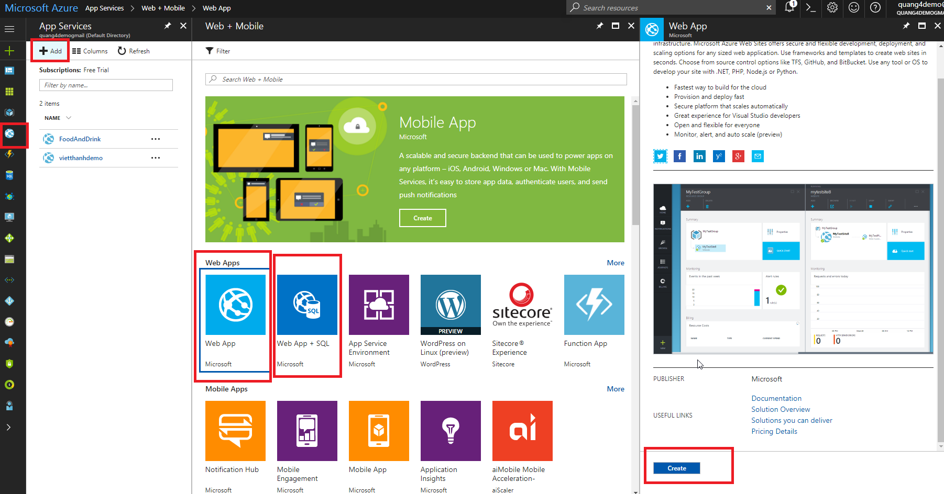

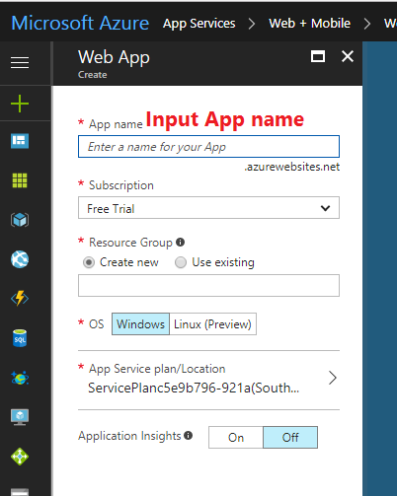

Get publish profile file

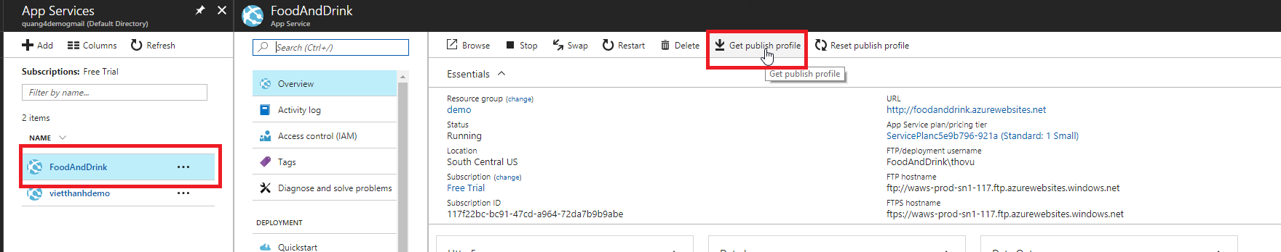

Go to VS, open Project, import this publish profile file

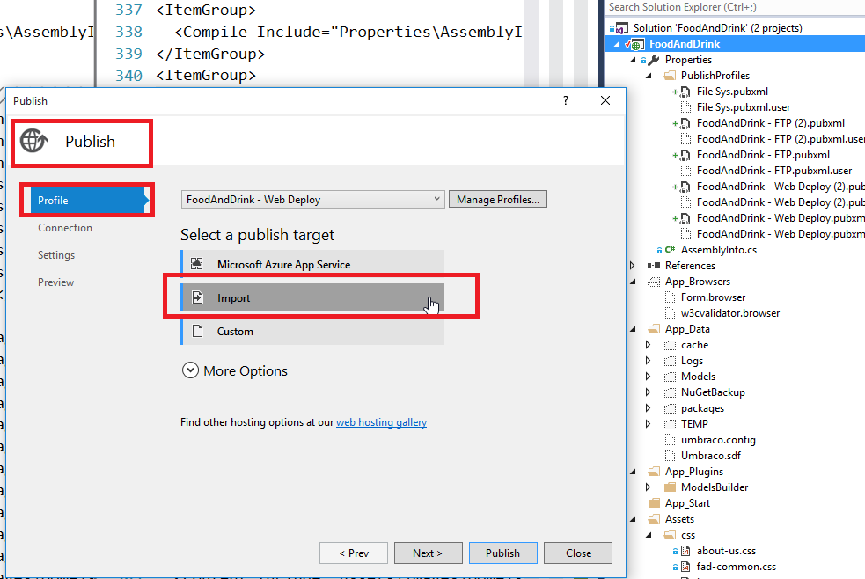

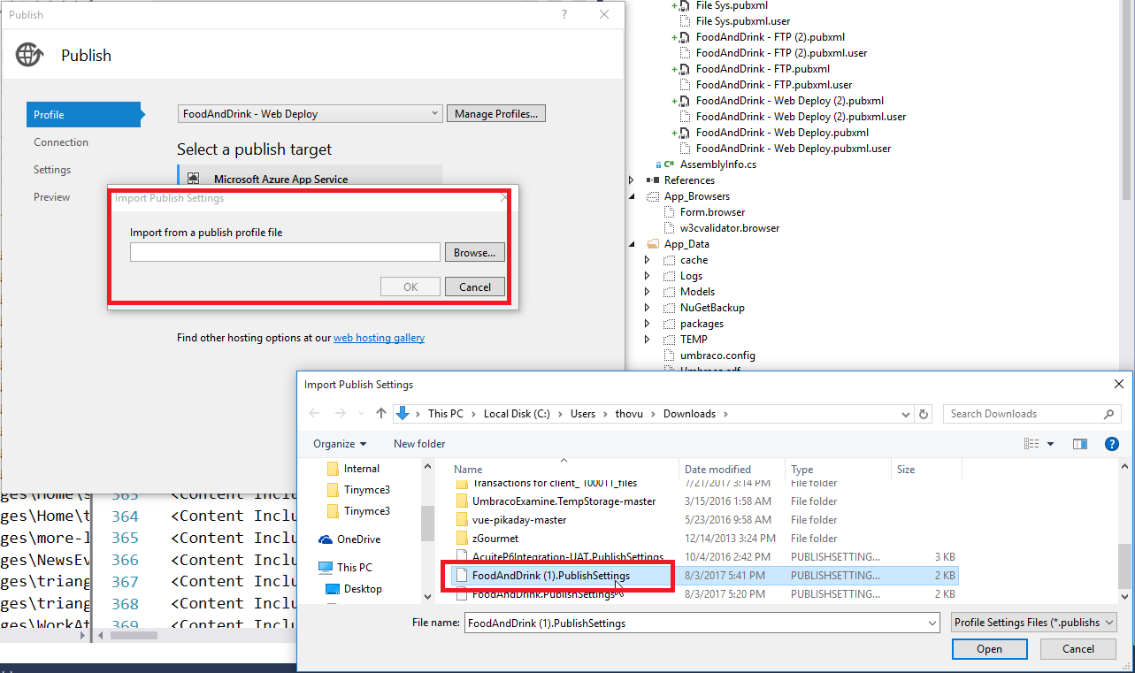

Now, we can publish the site to Azure

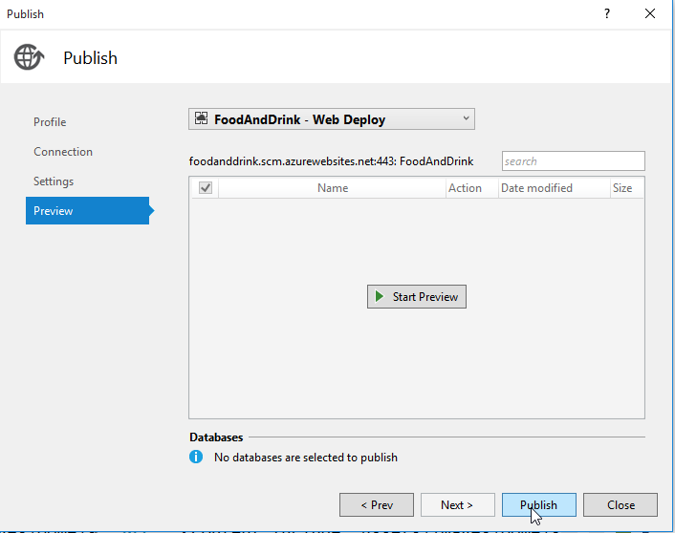

Note:

- these files are included in project will be published into Azure host